Dark Horse Katy Perry feat. Juicy J
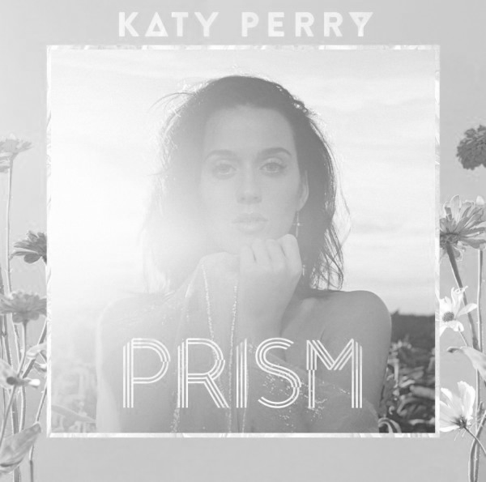
Written by Katy Perry, Jordan Houston, Lukasz Gottwald, Sarah Theresa Hudson, Max Martin and Henry Walter

I knew you were
You were gonna come to me
And here you are
But you better _______ carefully
‘Cause I am _______ of anything
Of anything and everything
Make me your Aphrodite
Make me your _______ and only
But don’t make me your enemy
Your enemy, your enemy
(Pre-Chorus)
So you wanna play with _______
Boy, you should know what you’re fallin’ for
Baby, do you _______ to do this
‘Cause I’m coming atcha like a dark horse
(Chorus)
Are you ready for, ready for
A perfect _______, perfect _______
‘Cause once you’re mine, once you’re mine
There’s no going back
Mark my words
This love will make you levitate
Like a bird
Like a bird without a _______
But down to earth
If you _______ to walk away
Don’t walk away
It’s in the _______ of your hand now, baby
It’s a yes or a no, no maybe
So just be sure

Before you give it all to me
All to me
Give it all to me
(Pre-Chorus)
(Chorus)
(Juicy J)
She’s a beast
I call her Karma
She’ll eat your _______ out
Like Jeffrey Dahmer
Be careful
Try not to lead her on
Shorty’s heart is on steroids
‘Cause her love is so strong
You may fall in love when you _______ her
If you get the chance, you better _______ her
She’s sweet as pie, but if you break her heart
She’ll turn cold as a _______
That fairy tale ending with a knight in shining armor
She can be my _______ _______
I’m gon’ put her in a coma
Now I think I love her
Shorty so bad, sprung and I don’t care
She ride me like a roller coaster
Turned the bedroom into a fair
Her love is like a drug
I was tryna hit it and quit it
But lil’ mama so dope
I messed around and got _______
(Pre-Chorus)
(Chorus)

