Robert gupta: Music is medicine, music is sanity

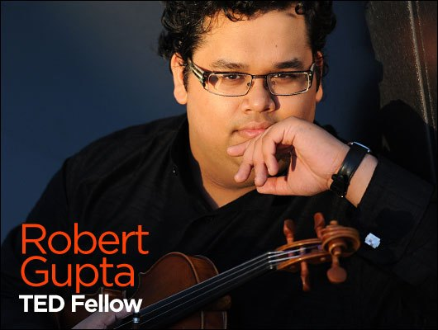
  - Gupta is a TED fellow and got a Master’s degree in music from Yale, after studying medicine for his undergraduate degree. A violinist with the Los Angeles Philharmonic, Gupta maintains a passionate parallel interest in neurobiology and mental health issues.

Comprehension

- What is Steve Lopez’s profession?
- What did Lopez hear on the streets of downtown LA?
- What happened to Nathaniel Ayers?
- How did Nathaniel act when Gupta first met him?
- Is Nathaniel receiving treatment for his condition?
- How did Nathaniel act the second time Gupta met him?
- Was Gupta afraid of Nathaniel?
- How did Nathaniel react when Gupta started playing the violin?

Fill in the blanks

0:00 One day, Los Angeles Times columnist Steve Lopez was walking along the streets of downtown Los Angeles when he heard beautiful music. And the source was a man, an African-American man, ___________, rugged, homeless, playing a violin that only had two strings.
0:32 And I'm telling a story that many of you know, because Steve's columns became the ________ for a book, which was turned into a movie, with Robert Downey Jr. acting as Steve Lopez, and Jamie Foxx as Nathaniel Anthony Ayers, the Juilliard-trained double bassist whose _____________ career was cut short by a tragic affliction with paranoid schizophrenia. Nathaniel dropped out of Juilliard, he suffered a complete breakdown, and 30 years later he was living ___________ on the streets of Skid Row in downtown Los Angeles. I encourage all of you to read Steve's book or to watch the movie to understand not only the beautiful bond that formed between these two men, but how music helped shape that bond, and ultimately was instrumental – ___ _______ ____________ ______ ______ -- in helping Nathaniel get off the streets.
1:20 I met Mr. Ayers in 2008, two years ago, at Walt Disney Concert Hall. He had just heard a performance of Beethoven's First and Fourth symphonies, and came backstage and introduced himself. He was speaking in a very jovial and gregarious way about Yo-Yo Ma and Hillary Clinton and how the Dodgers were never going to make the World Series, all because of the ______________ first violin passage work in the last movement of Beethoven's Fourth Symphony. And we got talking about music, and I got an email from Steve a few days later saying that Nathaniel was interested in a violin lesson with me.
1:52 Now, I should mention that Nathaniel refuses treatment because when he was treated it was with __________ therapy and Thorazine and handcuffs, and that scar has stayed with him for his entire life. But as a result now, he is prone to these schizophrenic episodes, the worst of which can ______________ themselves as him exploding and then disappearing for days, wandering the streets of Skid Row, exposed to its horrors, with the torment of his own mind unleashed upon him.
2:22 And Nathaniel was in such a state of agitation when we started our first lesson at Walt Disney Concert Hall -- he had a kind of _________ glint in his eyes, he was lost. And he was talking about invisible demons and smoke, and how someone was poisoning him in his sleep.
2:41 And I was afraid, not for myself, but I was afraid that I was going to lose him, that he was going ___ ________ into one of his states, and that I would ruin his relationship with the violin if I started talking about scales and arpeggios and other __________ forms of didactic violin pedagogy. (Laughter) So, I just started playing. And I played the first movement of the Beethoven Violin Concerto.
3:07 And as I played, I understood that there was a profound change occurring in Nathaniel's eyes. It was ___ ___ he was in the grip of some invisible pharmaceutical, a chemical reaction, for which my playing the music was its _________. And Nathaniel's manic rage was transformed into understanding, a ________ curiosity and grace. And in a miracle, he lifted his own violin and he started playing, by ear, __________ snippets of violin concertos which he then asked me to complete -- Mendelssohn, Tchaikovsky, Sibelius. _____ we started talking about music, from Bach to Beethoven and Brahms, Bruckner, all the B's, from Bartók, all the way up to Esa-Pekka Salonen.
3:57 And I understood that he not only had an encyclopaedic ___________ of music, but he related to this music at a personal level. He spoke about it with the kind of _________ and understanding that I share with my colleagues in the Los Angeles Philharmonic. And through playing music and talking about music, this man ____ transformed from the paranoid, disturbed man that had just come from walking the streets of downtown Los Angeles to the charming, erudite, brilliant, Juilliard-trained musician.
4:30 Music is medicine. Music changes us. And for Nathaniel, music is ________. Because music allows him to take his thoughts and delusions and shape them through his imagination and his creativity, into reality. And that is an _______ from his tormented state. And I understood that this was the very essence of art. This was the very reason why we made music, that we take something that exists within all of us at our very fundamental core, our ___________, and through our artistic lens, through our creativity, we're able to shape those emotions into reality. And the __________ of that expression reaches all of us and moves us, inspires and unites us.
5:19 And for Nathaniel, music __________ him back into a fold of friends. The redemptive power of music brought him back into a family of musicians that understood him, that _____________ his talents and respected him. And I will always make music with Nathaniel, whether we're at Walt Disney Concert Hall or on Skid Row, because he _____________ me why I became a musician. Thank you.

Vocabulary

Rage Agitation Rugged Pharmaceutical Affliction Personal Delusion Episode Torment Explode Disturbed

1. strong and simple; not delicate: ________________________________________________
2. something that makes you suffer: ______________________________________________
3. a single event or group of related events: ________________________________________
4. to break up into pieces violently, or to cause something to do this:____________________
5. great mental suffering and unhappiness, or great physical pain:______________________
6. worry and anxiety:__________________________________________________________
7. medicine:_________________________________________________________________
8. (a period of) extreme or violent anger:_________________________________________
9. relating to one person and not a group or an organization:_________________________
10. not thinking or behaving normally due to mental or emotional problems:_____________
11. belief in something that is not true:___________________________________________

Speech, speech!
Write a short speech (200-300 words) on one of the following topics and present it to your classmates. It can be in agreement with or arguing against the statement!
Music has the power to change people.
Medical treatments are not the answer for every condition.
My relationship with music is unique.

